SCV5018

ORETAN BARNABAS OLUWANISHOLA

MOVIE DATABASE MODEL QUERY

**-- 1 Write a query in SQL to find the name and year of the movies**.

select mov_title, mov_year

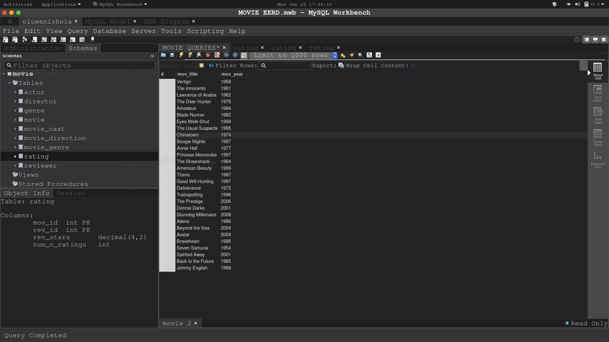from movie;

**-- 2 Write a query in SQL to find the year when the movie American Beauty released.**

select mov_year, mov_title

from movie

where mov_title = 'American Beauty';

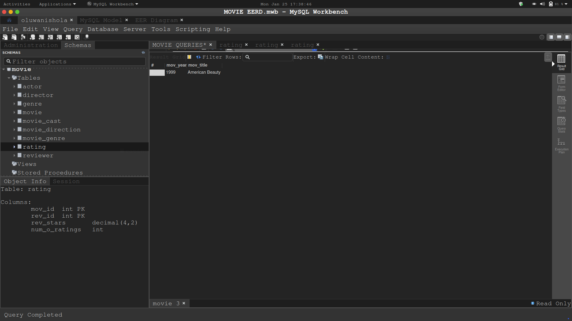

**-- 3 Write a query in SQL to find the movie which was released in the year 1999**

select mov_title, mov_year

from movie

w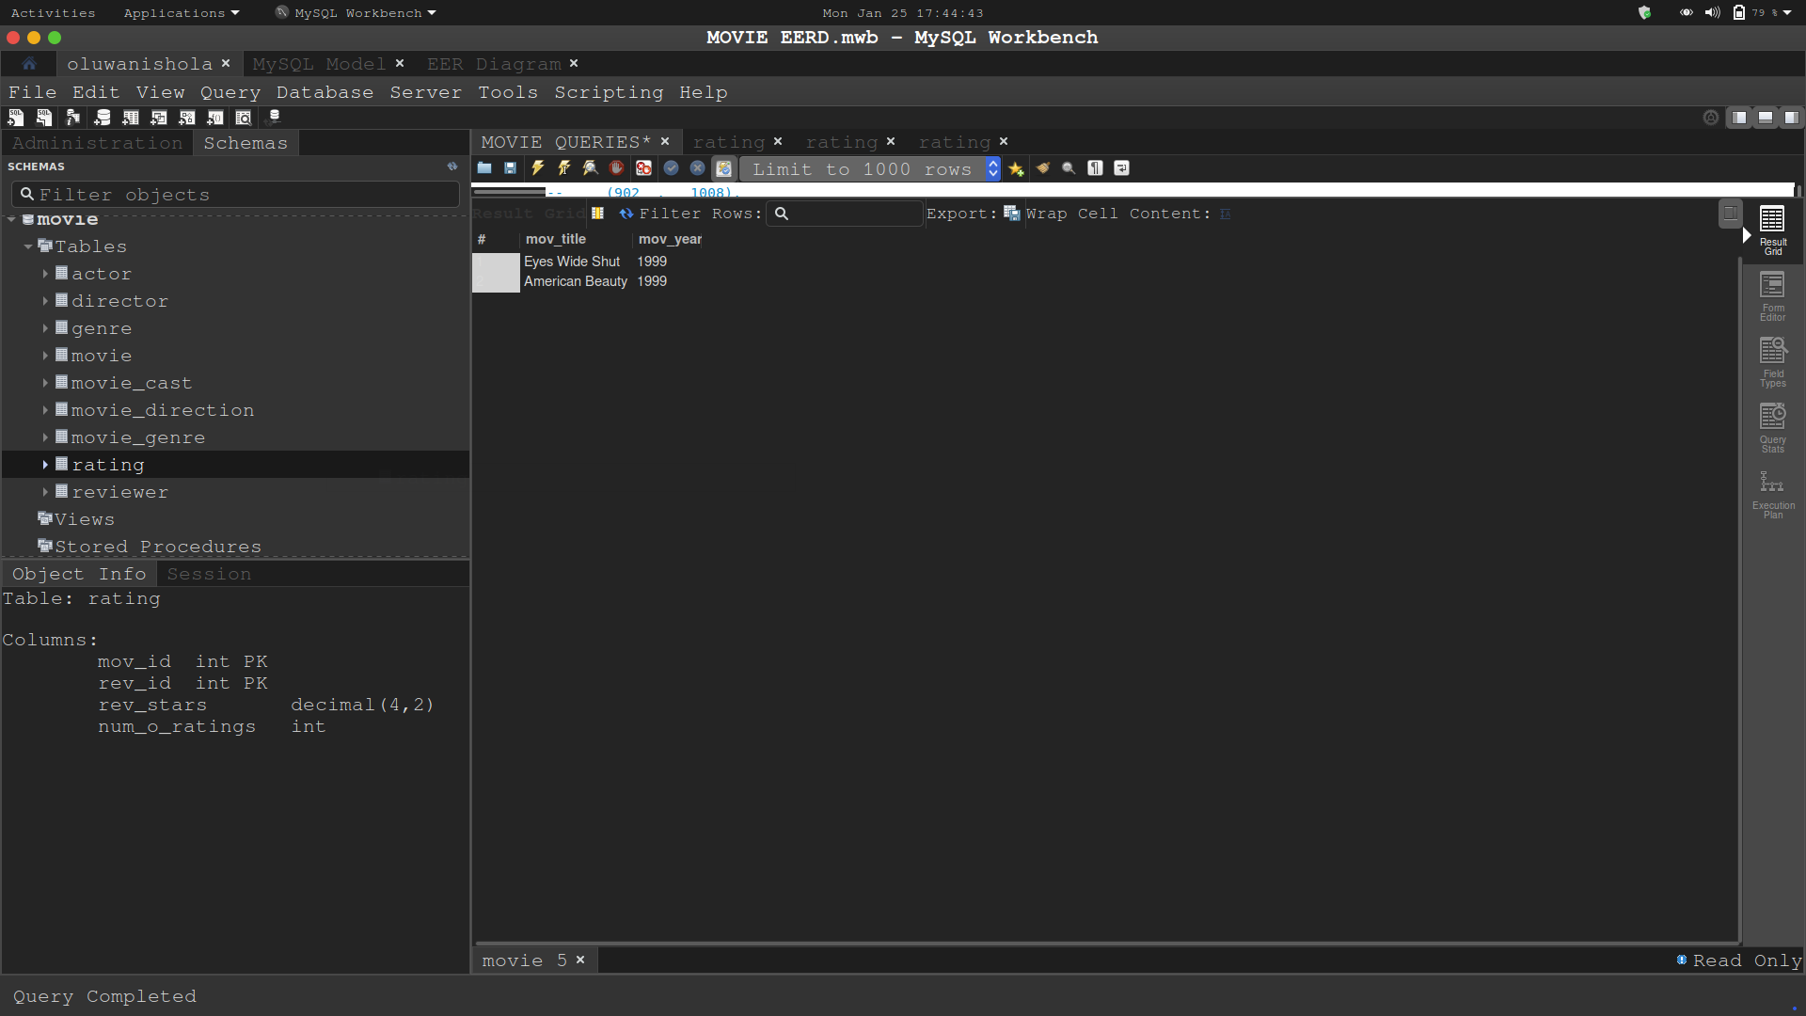here mov_year = 1999;

**-- 4 Write a query in SQL to find the movies which was released before 1998**

select mov_title, mov_year

from movie

where mov_year < 1998;

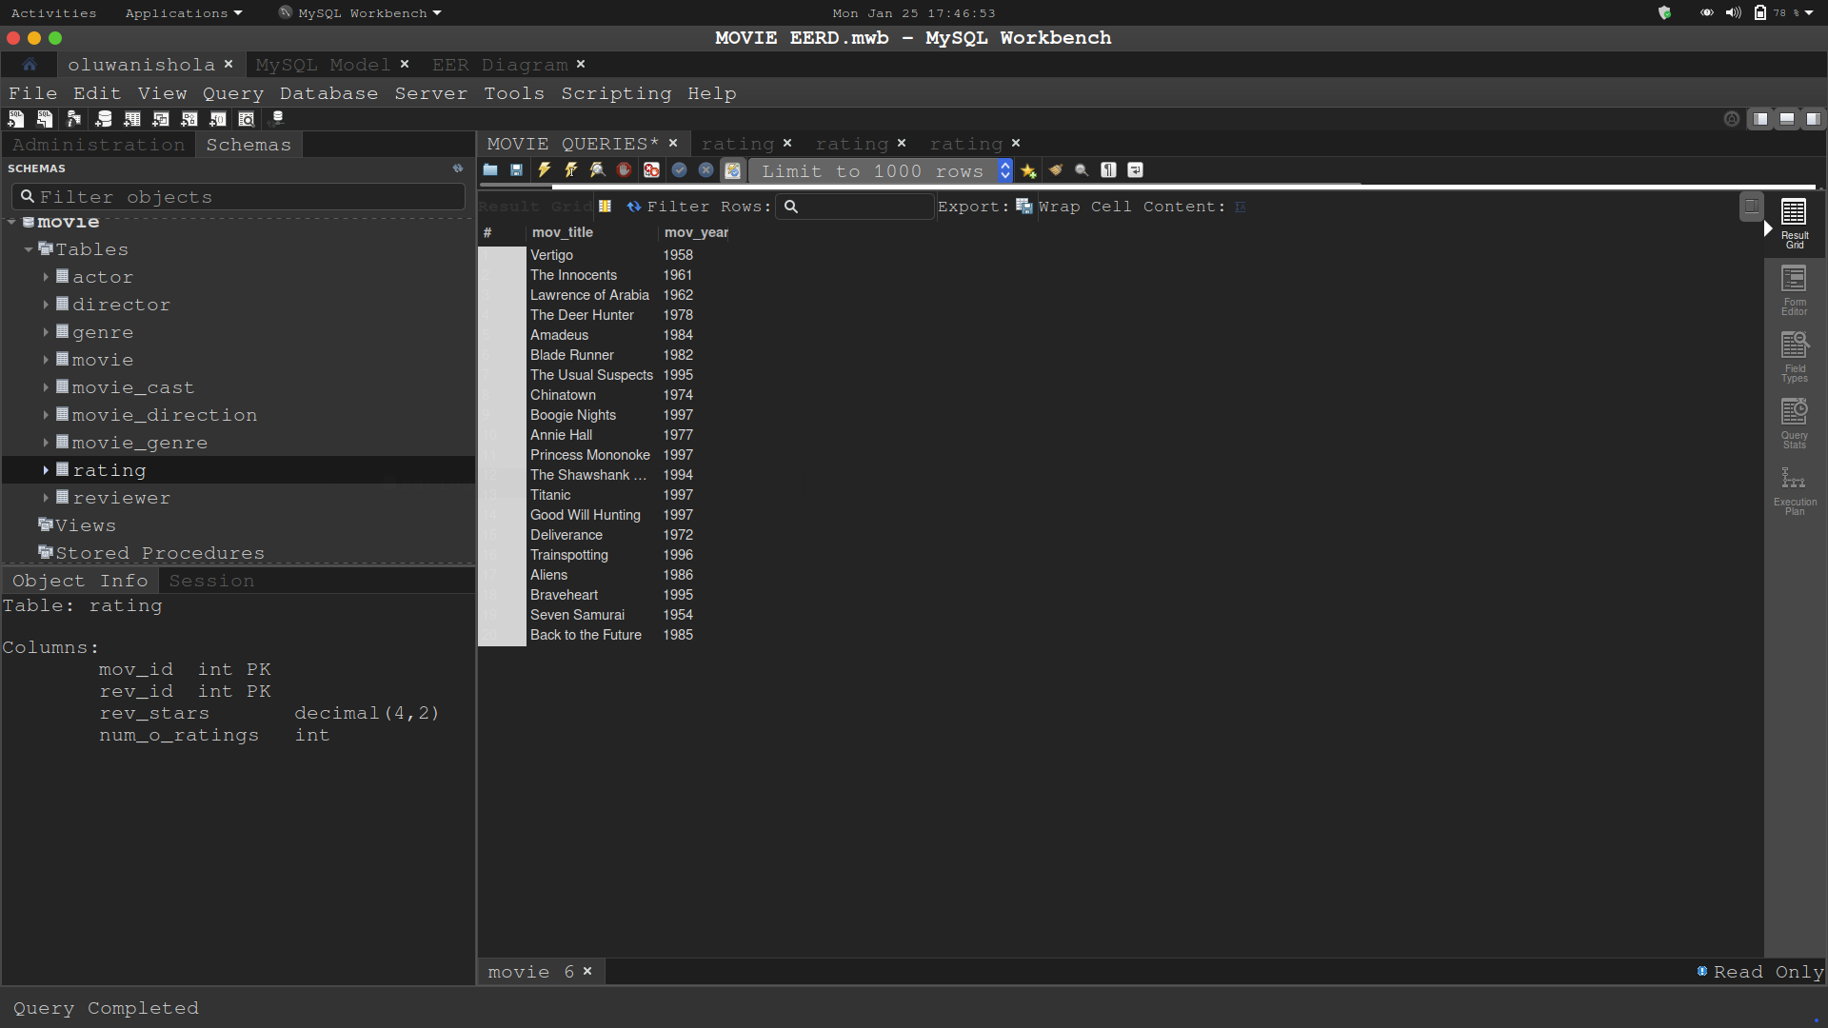

**-- 5 Write a query in SQL to find the movie which was released in the year 1999**

select mov_title, mov_year

from movie

where mov_year = 1999;

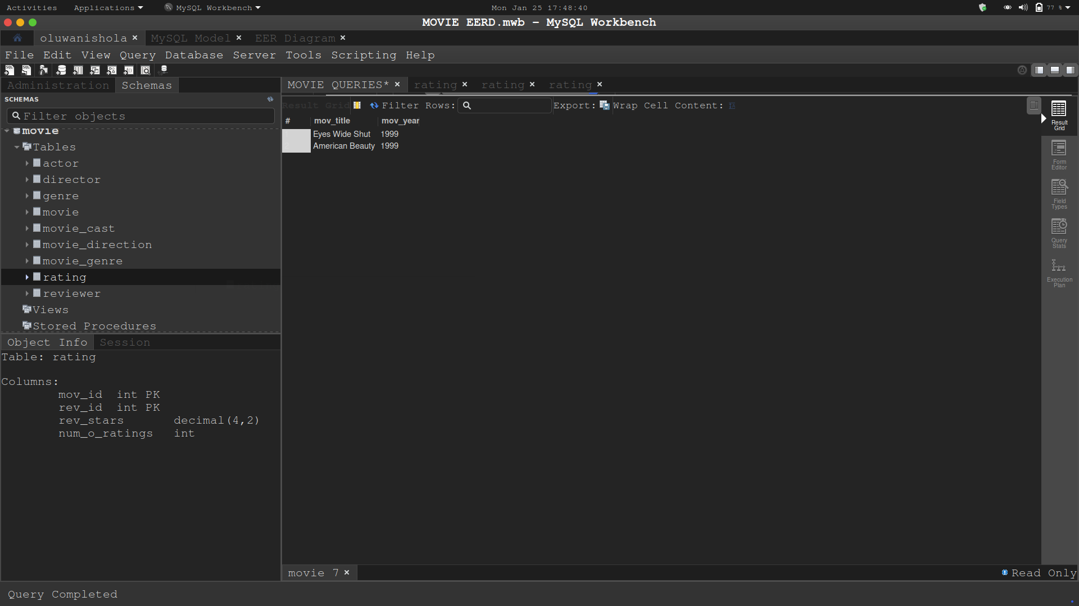

**-- 6 Write a query in SQL to return the name of all reviewers and name of movies together in a single list**

select rev_name, mov_title

from reviewer, movie;

select rev_name, mov_title

from reviewer

join movie

join rating

on rating.mov_id = movie.mov_id

and rating.rev_id = reviewer.rev_id;

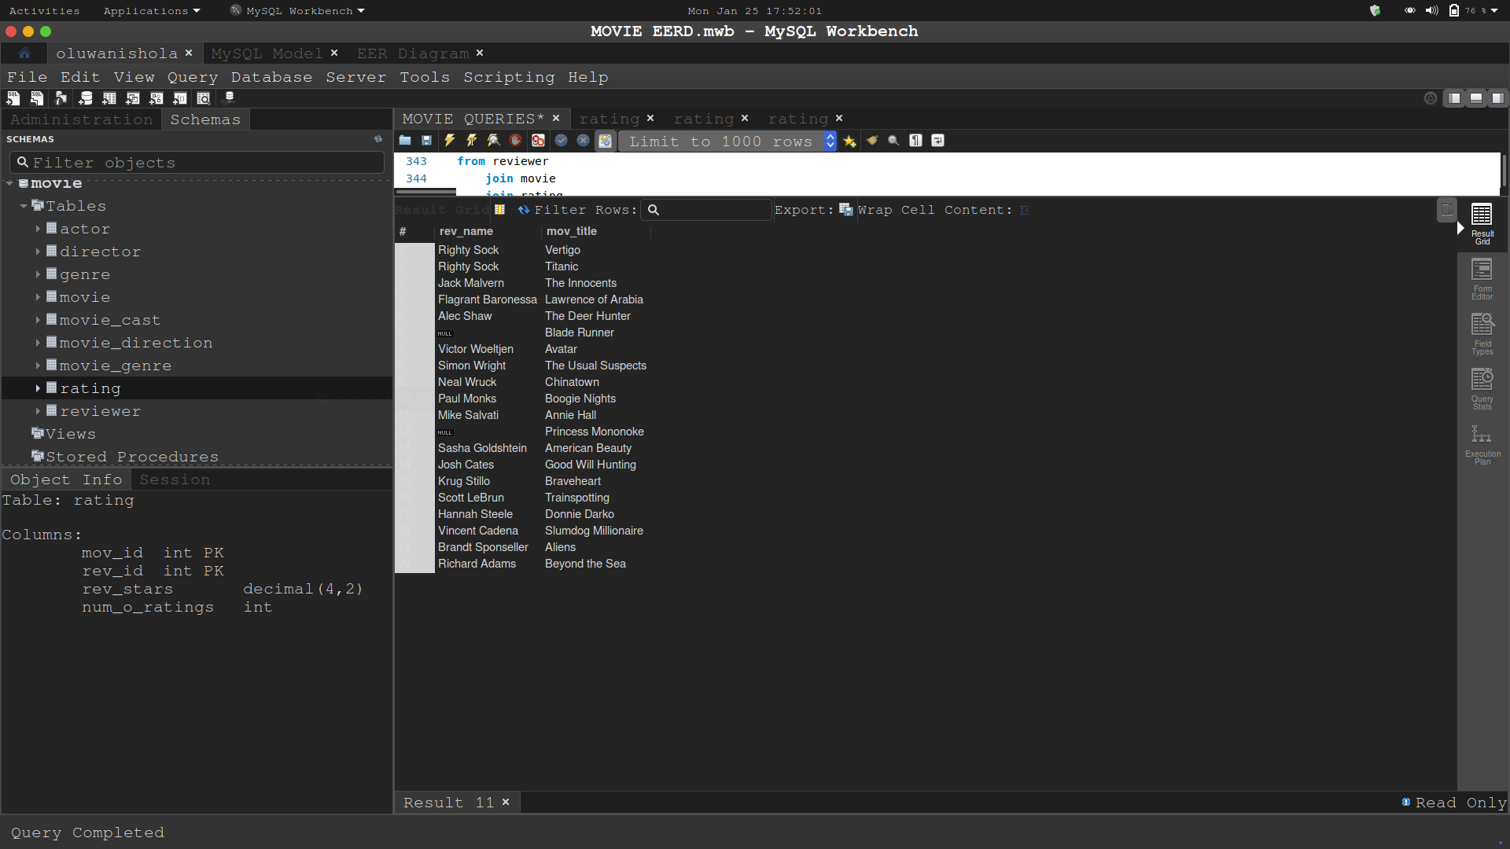

**-- 7 Write a query in SQL to find the name of all reviewers who have rated 7 or more stars to their rating**

select rev_name, rev_stars

from reviewer

join rating

on reviewer.rev_id = rating.rev_id

and rating.rev_stars >= 7;

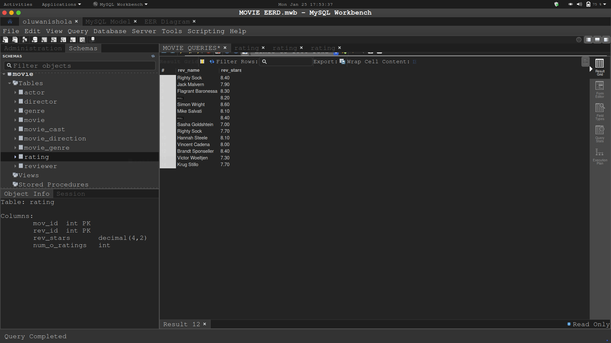

**-- 8 Write a query in SQL to find the titles of all movies that have no ratings.**

select mov_title, num_o_ratings

from movie join rating

on movie.mov_id = rating.mov_id

and num_o_ratings is null;

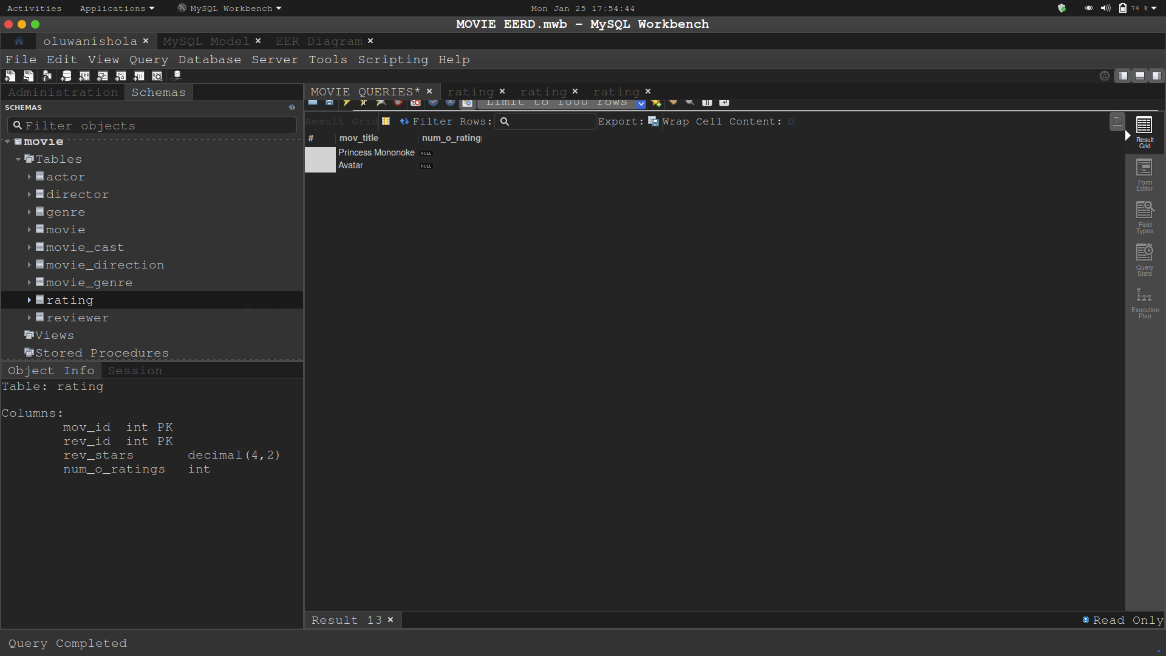

**-- 9 Write a query in SQL to find the name of all reviewers who have rated their ratings with a NULL value**

select rev_name, num_o_ratings

from reviewer

join rating

on reviewer.rev_id = rating.rev_id

and num_o_ratings is null;

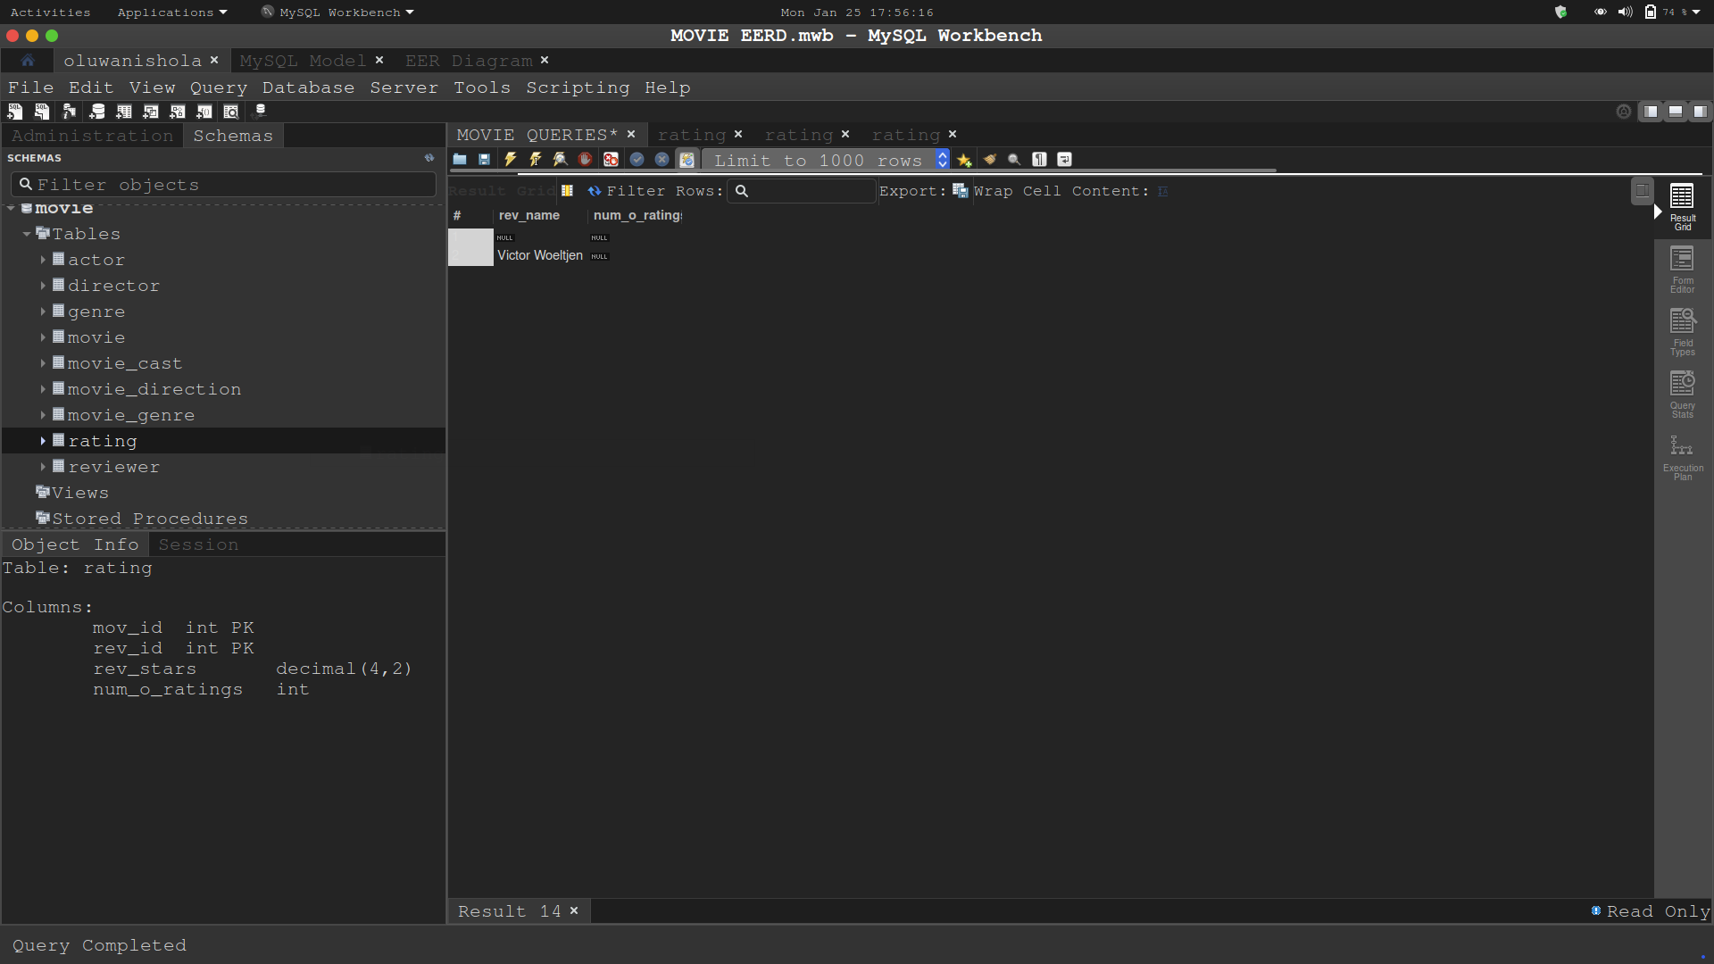

**-- 10 Write a query in SQL to find the name of movie and director (first and last names) who directed a**

**-- movie that casted a role for 'Eyes Wide Shut'.**

select mov_title, concat(dir_fname, ' ', dir_lname) as 'Director'

from movie

join director

join movie_direction

on movie.mov_id = movie_direction.mov_id

and director.dir_id = movie_direction.dir_id

and mov_title = 'Eyes Wide Shut';

